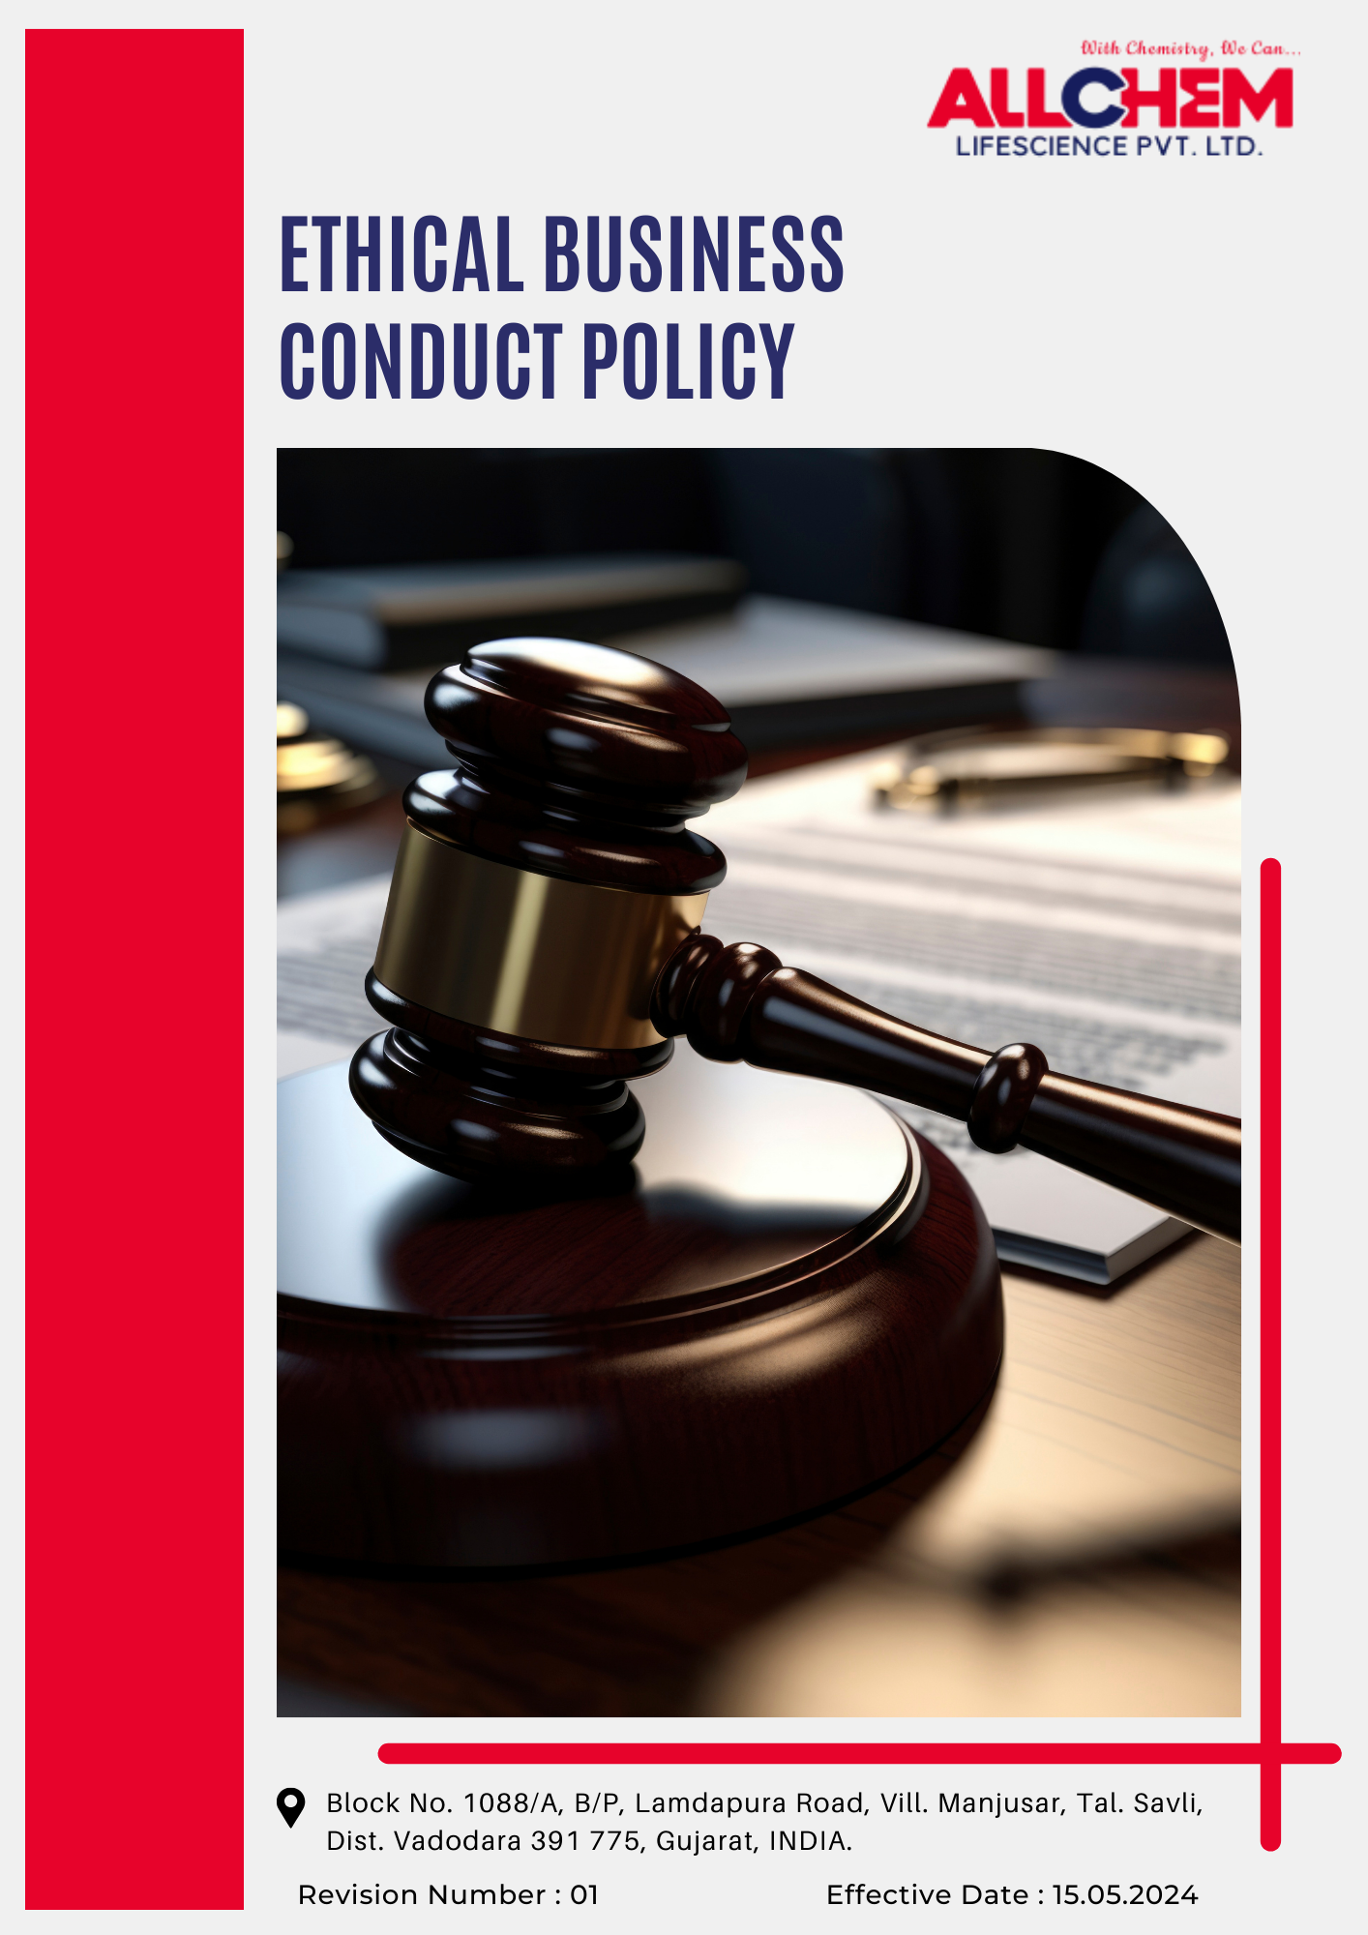

Contents
Preface 3
Scope 3
Policy Declaration 3
Key Action Areas 3
Targets based on our action areas 4
Examples and Guidance: 5
Our Targets in alignment with SDGs: 7
Continuous Improvement: 7
Addressing Policy Violations: 8
Responsibility 8
Review Mechanism: 9
Employee Acknowledgment Form 10

Preface
At Allchem Lifescience Pvt. Ltd., ethical conduct forms the cornerstone of our business. We are dedicated to upholding integrity, transparency, and accountability in every aspect of our operations. This policy provides clear guidance on ethical decision-making, legal compliance, and the values that define our organization.
By maintaining the highest ethical standards, we foster trust, enhance credibility, and build strong relationships with stakeholders. This policy underscores our commitment to anti-corruption, fair competition, information security, and responsible business practices, ensuring sustainable growth and long-term success.
Scope
This policy applies to all employees, management, contractors, suppliers, and business associates of Allchem Lifescience Pvt. Ltd. It sets clear expectations for ethical behavior, legal compliance, and responsible business conduct across all operations and stakeholder interactions.
Allchem Lifescience Pvt. Ltd. | Block No. 1088/A, B/P, Lamdapura Road, Vill. Manjusar, Tal.-Savli, Dist.-Vadodara -391 775, Gujarat, India.

Policy Declaration
Integrity and inclusivity are fundamental to the workplace culture at Allchem Lifescience Pvt. Ltd. With 2022 as the baseline year for our commitments, we are dedicated to ethical business practices, regulatory compliance, and responsible stakeholder engagement. Through robust governance, ongoing training, and collaboration, we continuously strengthen our ethical standards.
Key Action Areas
- Strict enforcement of zero-tolerance policy against bribery, corruption, and unethical business practices and regularly monitoring it.
- Mandating employees and business partners to disclose conflicts of interest and ensuring all decisions align with the company's ethical standards.
- Strengthening anti-fraud controls through regular audits, transparent reporting mechanisms, and swift action against fraudulent activities.
- Ensuring full compliance with financial regulations by conducting a thorough due diligence, and maintaining transparency in all financial transactions.
- Protecting sensitive business and client data with robust cybersecurity protocols, secure data management practices, and continuous employee training.
- Promoting fair competition by prohibiting unethical business practices, ensuring transparent dealings, and building trust with stakeholders.
- Secure and anonymous channels for employees and stakeholders to report unethical conduct without the risk of retaliation.
- Complying with all relevant local and international laws, regularly updating policies to align with regulatory changes, and providing compliance training to reinforce ethical responsibilities.
Targets based on our action areas
- Corruption and Unethical Practices
- Conduct thorough background checks and due diligence on all new suppliers and contractors, achieving 100% compliance by year 2028.
- Foster a culture of ethical conduct by providing mandatory annual training on integrity and anti-corruption & bribery for all employees.
- Regularly assess and enhance the confidentiality and effectiveness of the whistleblower system to ensure seamless reporting of corruption-related concerns.
- Ensure that every corruption-related report is reviewed, investigated, and addressed with necessary corrective actions within 30 days.
- Guarantee that 100% employees, suppliers, and contractors in high-risk positions complete specialized anti-corruption training annually.

- Managing Conflicts of Interest
- Implement a structured disclosure system with mandatory reporting forms, periodic audits, training programs, and a confidential reporting mechanism to prevent and address conflicts of interest.
- Maintain the strict enforcement of clear guidelines to prevent favoritism, nepotism, and undue influence in business dealings.
- Maintain 100% annual compliance in conflict of interest disclosure submissions from senior management and procurement teams by year 2028.
- Address and resolve 100% of reported conflict of interest cases within 45 days, ensuring appropriate actions are taken by year 2028.

- Fraud Prevention and Detection Mechanisms
- Ensure 100% of high-value financial transactions undergo independent verification before approval to enhance financial transparency and accountability.
- Strengthen internal controls and financial monitoring systems to detect and prevent fraudulent activities.
- Maintain strict implementation of zero-tolerance policy for fraudulent behavior with clear disciplinary measures and enforcement protocols.
- Strengthen internal controls and awareness programs to maintain zero reported fraud incidents till year 2028.
- Conduct fraud risk assessments annually and implement corrective actions to reduce identified risks by 30% by year 2028.

- Strengthening Anti-Money Laundering Controls
- Enhance financial monitoring systems to identify, track, and report suspicious transactions in compliance with regulatory requirements.
- Strengthen adherence to anti-money laundering (AML) regulations through regular updates, policy enhancements, and mandatory training for key personnel.
- Provide annual AML training to 100% of employees in finance, procurement, and compliance departments to improve risk awareness and reporting accuracy.
- Implement an automated transaction monitoring system by 2028 to enable real-time detection and flagging of suspicious activities, reducing exposure to money laundering threats.
- Conduct thorough AML compliance screenings for 100% suppliers and financial transactions exceeding regulatory thresholds to mitigate financial crime risks.

- Enhancing Information Security and Data Protection
- Enforce stringent information security protocols to protect sensitive business, employee, and client data from unauthorized access, breaches, and cyber threats.
- Conduct mandatory annual cybersecurity training for 100% employees, covering data privacy, phishing prevention, and risk mitigation strategies.
- Ensure 100% compliance with information security audits conducted across all departments by year 2028.
- Maintain zero incidents of unauthorized data access and breaches through improved controls by year 2028.

- Promoting Fair Business Practices
- Ensure 100% transparency in all contracts and pricing mechanisms, with annual external audits.
- Implement supplier due diligence processes, ensuring 100% of high-risk suppliers undergo ethical compliance assessments regularly.
- Strengthening Ethical Reporting and Whistleblower Protection
- Conduct awareness sessions annually to educate employees and stakeholders on ethical reporting procedures, whistleblower rights, and protection policies.
- Implement secure, anonymous, and easily accessible reporting channels for 100% of employees and stakeholders to report ethical concerns without fear of retaliation.
Examples and Guidance:
1. Corruption and Unethical Practices
- Example: A supplier offers an employee an expensive gift for preferential treatment.
- Guidance: The employee must decline the gift and report it to the compliance team. Accepting such offers violates anti-bribery policies. Employees should follow ethical guidelines and use the whistleblower system for reporting concerns.
2. Managing Conflicts of Interest
- Example: A procurement manager finds that a bidding vendor is owned by a close relative.
- Guidance: The manager must disclose the conflict and recuse themselves from the selection process. Transparency is key to maintaining fairness in business dealings.
3. Fraud Prevention and Detection
- Example: A finance executive notices unusually high reimbursements in a colleague’s expense reports.
- Guidance: The discrepancy must be reported immediately to the audit team. Employees should be vigilant and use fraud detection mechanisms to prevent financial misconduct.
4. Anti-Money Laundering Controls
- Example: A customer requests to split a large payment into multiple small transactions.
- Guidance: The transaction should be flagged for review. Employees must adhere to AML regulations and report suspicious activities to prevent financial crimes.
5. Information Security and Data Protection
- Example: An employee receives an email from "IT support" requesting login credentials.
- Guidance: The email should be reported as a phishing attempt. Employees must follow security protocols and never share confidential information.
6. Fair Business Practices
- Example: A customer demands an unregistered discount in exchange for securing a contract.
- Guidance: The request should be denied and reported to compliance. Employees must ensure transparency and fairness in all business dealings.
7. Ethical Reporting and Whistleblower Protection
- Example: An employee sees a senior manager manipulating financial reports but fears retaliation.
- Guidance: The misconduct should be reported via the whistleblower hotline, which ensures anonymity. The company must protect employees from retaliation and promote ethical reporting.
Our Targets in alignment with SDGs:
- SDG 8: Decent Work and Economic Growth – Promoting fair business practices by enforcing anti-money laundering controls, fraud prevention mechanisms, and financial transparency to ensure ethical economic activities.
- SDG 9: Industry, Innovation, and Infrastructure – Strengthening cybersecurity, data protection measures, and automated monitoring systems to enhance resilience against financial crimes and unauthorized access.
- SDG 10: Reduced Inequalities – Ensuring equal access to ethical reporting mechanisms, safeguarding whistleblowers, and preventing favoritism or undue influence in decision-making.
- SDG 12: Responsible Consumption and Production – Implementing supplier due diligence, ethical procurement, and transparency in supply chain management to uphold responsible business practices.
- SDG 16: Peace, Justice, and Strong Institutions – Combating corruption, bribery, and financial misconduct through strict compliance measures, independent audits, and mandatory training programs.
Continuous Improvement:
Ethical business practices at Allchem Lifescience Pvt. Ltd. are continuously strengthened to align with evolving regulations, industry benchmarks, and emerging risks. A culture of integrity is deeply embedded, ensuring transparency, compliance, and accountability at all levels.
- Ongoing Training & Awareness: Employees receive annual training on anti-corruption, conflict of interest management, fraud prevention, AML compliance, and information security.
- Comprehensive Risk Assessments & Audits: Regular internal evaluations and independent external audits identify potential risks, assess policy effectiveness, and implement corrective measures.
- Collaborative Compliance Approach: Engagement with industry bodies and regulatory authorities ensures adherence to ethical standards and best practices.
- Advanced Monitoring & Reporting: Secure digital platforms and automated risk detection tools enhance fraud prevention, compliance tracking, and incident reporting.
- Continuous Improvement & Transparency: Open feedback mechanisms empower employees and stakeholders to contribute insights, fostering a culture of continuous ethical enhancement.

Addressing Policy Violations:
Allchem Lifescience Pvt. Ltd. upholds a zero-tolerance approach to ethical violations, including corruption, conflicts of interest, fraud, money laundering, and information security breaches. Strict corrective actions are enforced to maintain integrity and transparency across operations.
Reporting Mechanism
- Employees, suppliers, and stakeholders can report suspected violations through a confidential whistleblower system that ensures anonymity and protection from retaliation.
- All reports are handled with strict confidentiality, and appropriate measures are taken to investigate and address concerns promptly.
Investigation & Disciplinary Actions
- The Compliance Officer leads investigations, collaborating with internal teams or external auditors when necessary.
- Violations may result in disciplinary actions, including warnings, suspension, termination, or legal proceedings.
- Suppliers found in breach may face contract suspension, penalties, or blacklisting to uphold ethical supply chain standards.
Corrective & Preventive Actions
- Remedial measures such as process enhancements, additional training, or stricter controls are implemented to prevent recurrence.
- Insights from major breaches contribute to ongoing risk assessments and policy refinements to strengthen ethical governance.
Responsibility
A strong ethical culture requires accountability at all levels of the organization. The following roles are responsible for upholding and enforcing this policy:
- Senior Management ensures ethical business practices and regulatory compliance across all operations.
- The Compliance Officer oversees policy implementation, training, and investigations.
- Department Heads and Supervisors ensure ethical standards are integrated into daily operations.
- Finance and Procurement Teams conduct due diligence to mitigate corruption, fraud, and money laundering risks.
- All Employees adhere to ethical standards, report violations, and complete mandatory training.

Review Mechanism:
- The Ethics Officer conducts a policy review biennially or earlier to address regulatory updates, emerging risks, or operational changes.
- Insights from risk assessments, internal audits, employee feedback, and reported ethical concerns are analyzed to strengthen policy enforcement.
- Revisions are implemented as needed, with updated policies communicated to employees, suppliers, and stakeholders to ensure continued compliance and awareness.
- Periodic training sessions are conducted to familiarize employees with policy updates and reinforce ethical standards.
- A structured feedback mechanism is in place to gather suggestions and concerns, fostering continuous improvement in ethical governance.

Effective Date | : 15.05.2024
Next Review Date | : 15.05.2026
Approved By | :

Employee Acknowledgment Form
I acknowledge that I have received, read, and understood the Ethical Business Practices Policy of Cherry Hill Interiors Pvt. Ltd. I agree to uphold the principles outlined in this policy, including preventing corruption, managing conflicts of interest, combating fraud, ensuring compliance with anti-money laundering regulations, and safeguarding information security.
I understand that it is my responsibility to adhere to this policy in all professional activities and to report any ethical concerns or violations through the designated reporting channels. I acknowledge that non-compliance may result in disciplinary action in accordance with company regulations.
By signing this acknowledgment, I confirm my commitment to integrity, transparency, and ethical conduct in all aspects of my work.

Employee Name  Employee ID  Date  Signature | :_______________________________  :_______________________________ :________________________________  : _______________________________

